Cloud-Based Website Project

Syeda Masooma Zehra Naqvi - 35151996

ZEROXDXB

Steps Followed in Cloud-Based Website Deployment Project

1. **HTML Code Development:**

The first step of my assignment involved designing the website. I created three main HTML pages:

* index.html: The homepage of the website.
* destination.html: A page showcasing selected destinations.
* about.html: A page providing information about the website.

These HTML files formed the core content and structure of my website.

1. **Setting Up a Virtual Private Server (VPS) using Amazon Web Services (AWS):**

Once my website files were ready, I proceeded to AWS to create a VPS using the EC2 (Elastic Compute Cloud) service. I launched a new instance to act as a remote server that would host my website.   
EC2 Instance Configuration Includes:

* Operating System: Ubuntu 22.04 LTS
* Instance Type: t3.micro (eligible for free tier)  
  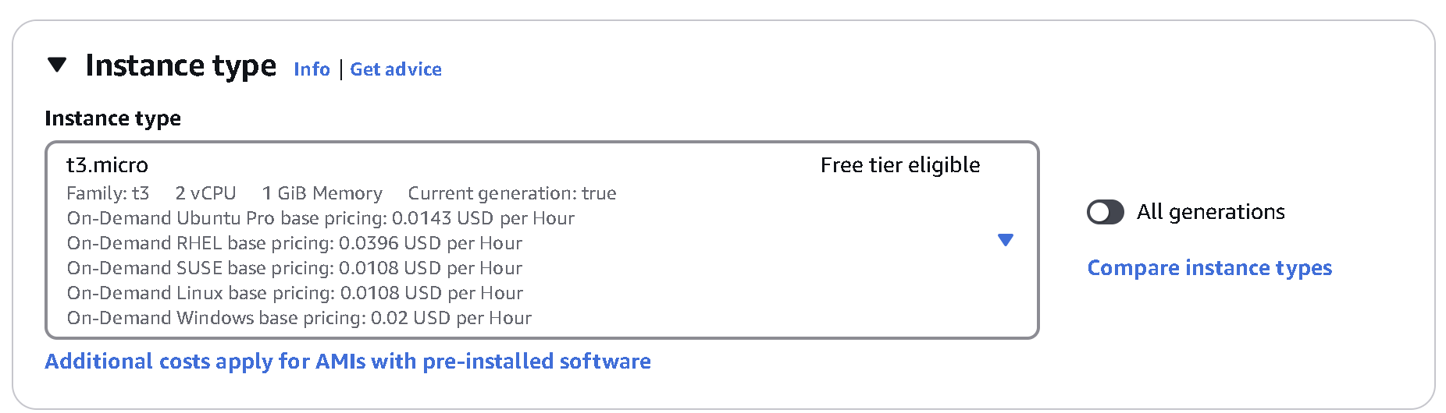
* Security Group Rules: Allowed inbound access on port 22 (SSH) and port 80 (HTTP)

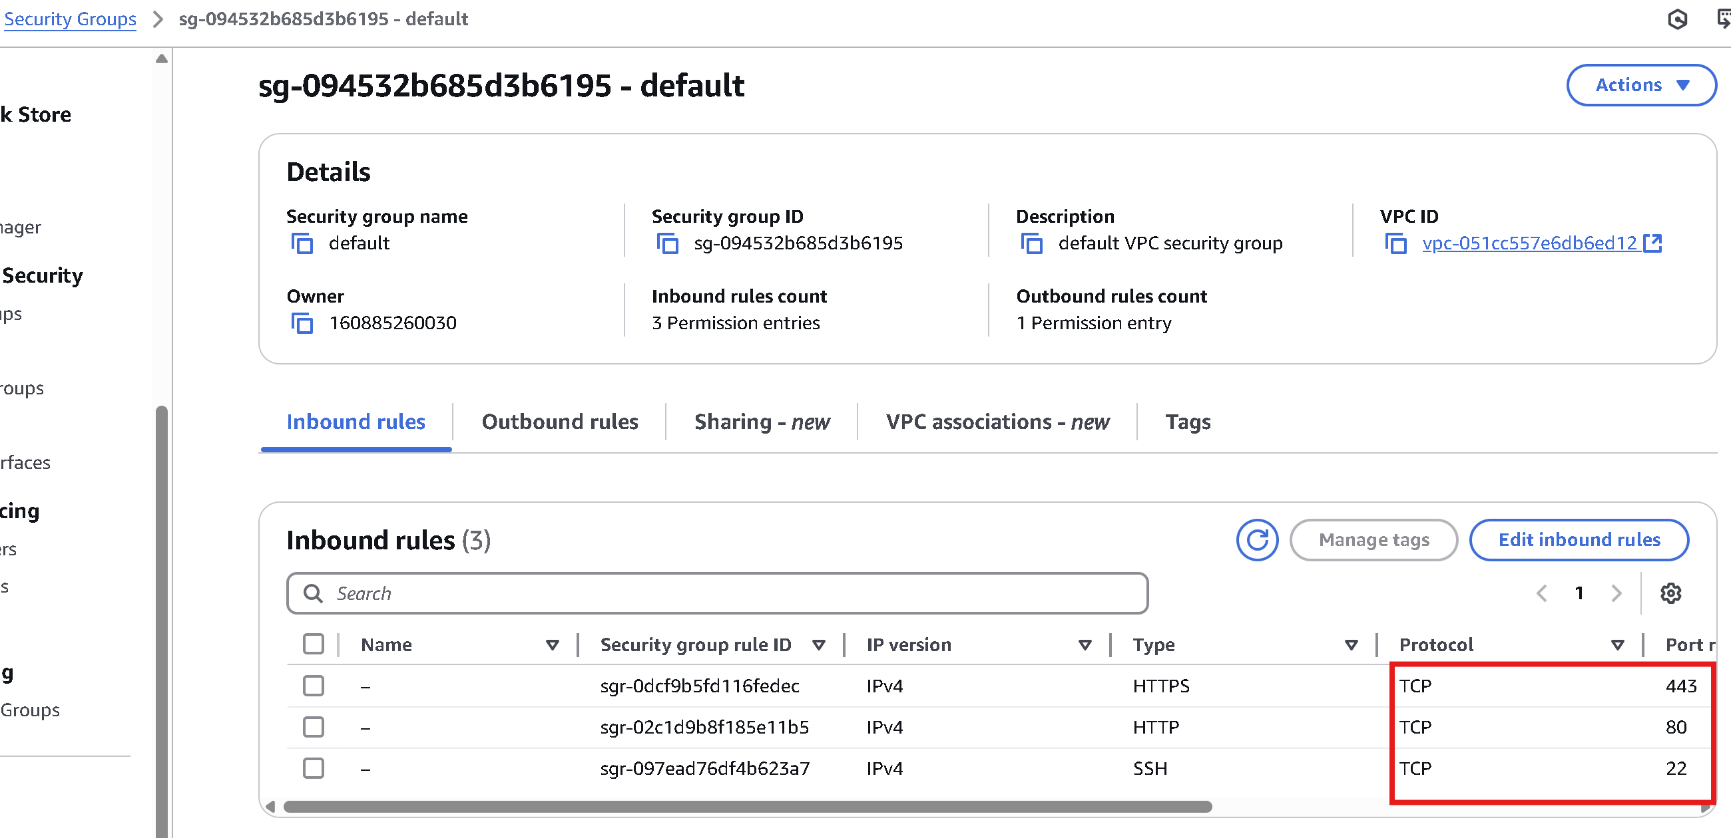

1. **Accessing the Server via Ubuntu Terminal**:

After launching the EC2 instance, I accessed the server using SSH from an Ubuntu terminal. I logged in to the server using the .pem key file provided by AWS. This gave me full control of the server environment.

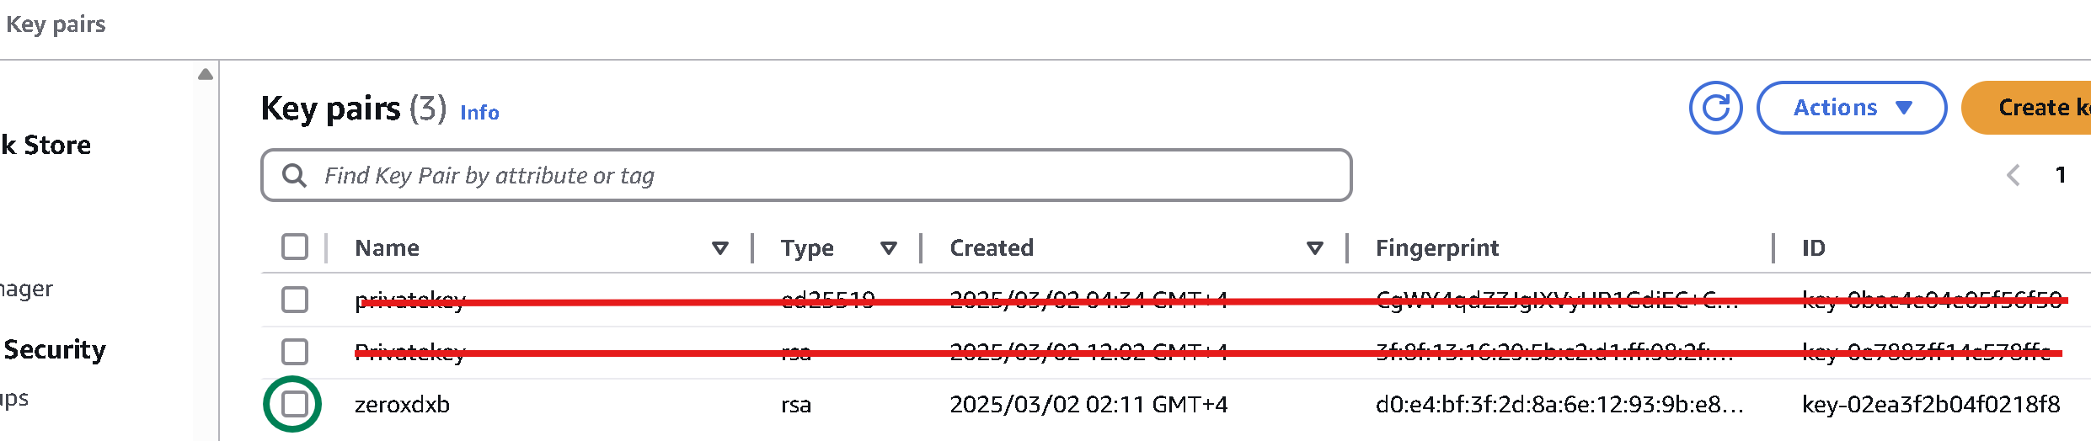

1. **Uploading HTML Files to the Web Server**:

Once connected to the server, I uploaded my HTML files to the server. This process involved transferring files from my local machine to the server's file system.

Make sure the EC2 instance has SSH access enabled, which is required for SFTP transfers. If you're using a default Ubuntu-based EC2 instance, SSH (and thus SFTP) should be enabled by default, but it's always good to double-check.

* **Exact Commands for SSH and Upload**

The following command was used to connect to the EC2 server:

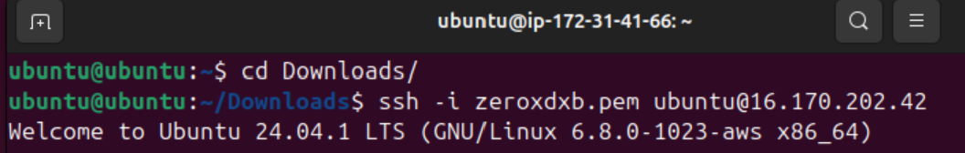

SSH, which stands for Secure Shell, is a network protocol used to establish a secure and encrypted connection between a local computer and a remote server over an unsecured network. It allows users to remotely access and manage servers through a command-line interface.

In the context of this assignment, SSH was used to connect from a local terminal (on my computer) to the Amazon EC2 instance (a virtual private server hosted on AWS). This connection enabled me to execute commands directly on the remote server, such as uploading files, installing software (e.g., Apache), and managing web services. SSH ensures that all data transferred between the client and the server is encrypted, protecting it from eavesdropping and unauthorized access.

* **Using FileZilla with SFTP for File Transfer**  
  To upload files, I used **FileZilla Client**, a free and user-friendly FTP tool. Instead of regular FTP, I used **SFTP (Secure File Transfer Protocol)**, which works over SSH to securely transfer files.
* **Why I chose FileZilla with SFTP:**
* It provided a graphical interface that made it easier to navigate and manage files without using complex command-line tools.
* SFTP ensured the file transfer was encrypted and secure.
* It allowed me to easily drag and drop my HTML files into the server’s file system.
* **Steps to Use FileZilla Client with EC2:**

1. Install FileZilla Client from the official website.
2. Open FileZilla and go to **File > Site Manager**.
3. Click **New Site** and configure the connection:
   1. **Host:** Public IP of your EC2 instance
   2. **Protocol:** SFTP – SSH File Transfer Protocol
   3. **Logon Type:** Key file
   4. **User:** ubuntu
   5. **Key File:** Select your .pem private key file
4. Click **Connect** to establish the secure SFTP connection.

This method successfully uploaded my website files to the EC2 instance, preparing them to be served through Apache.

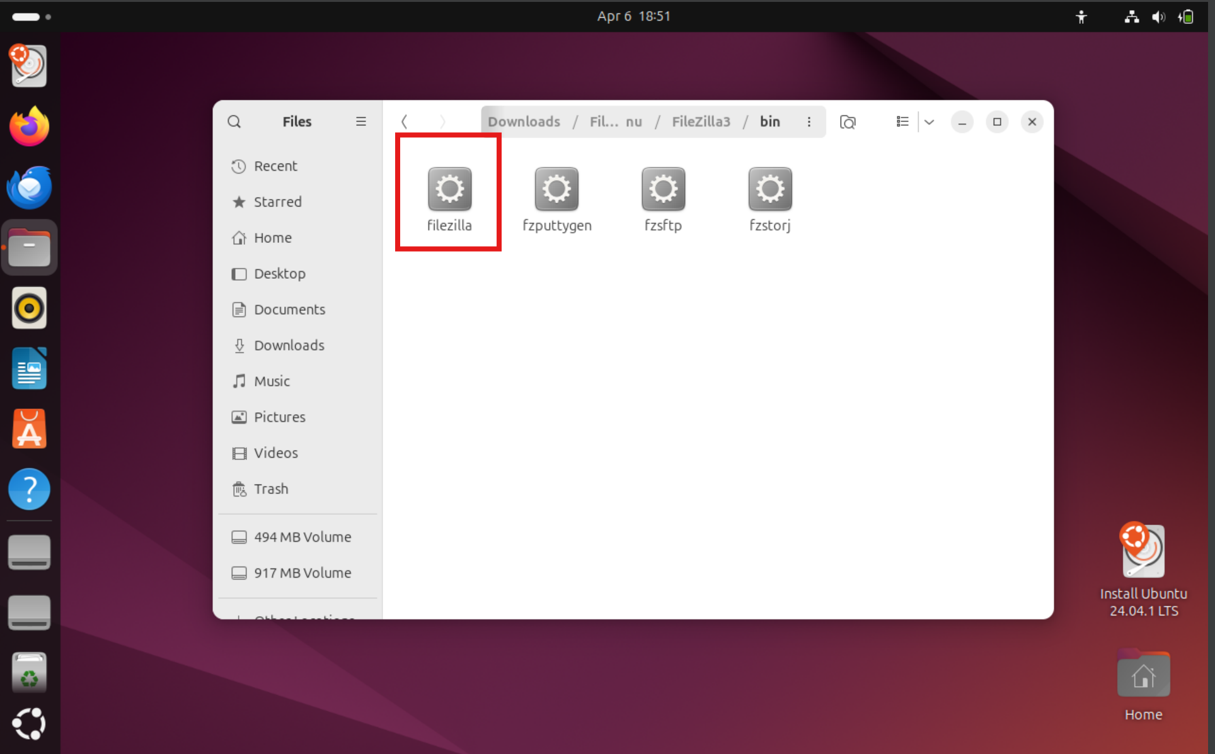

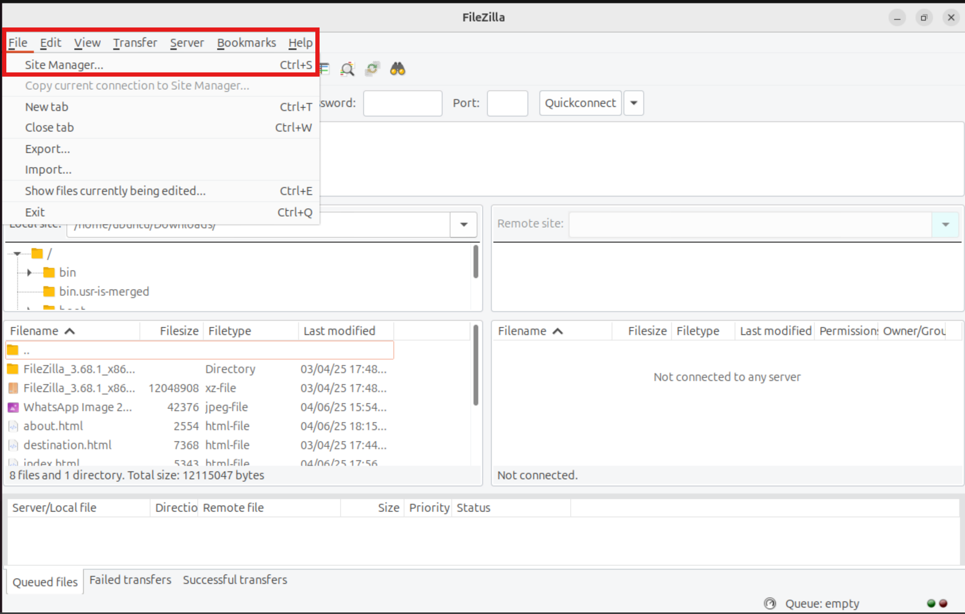

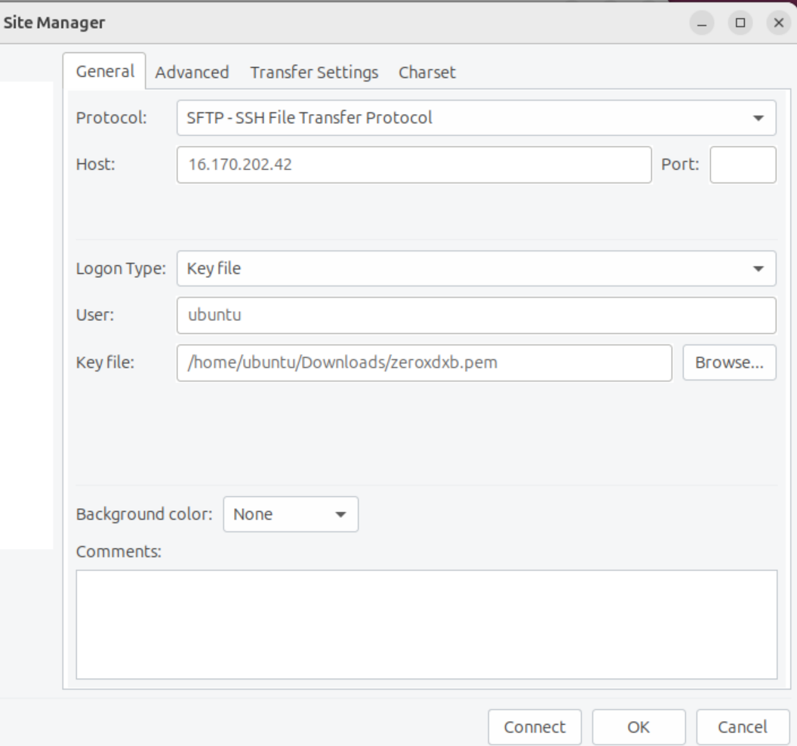

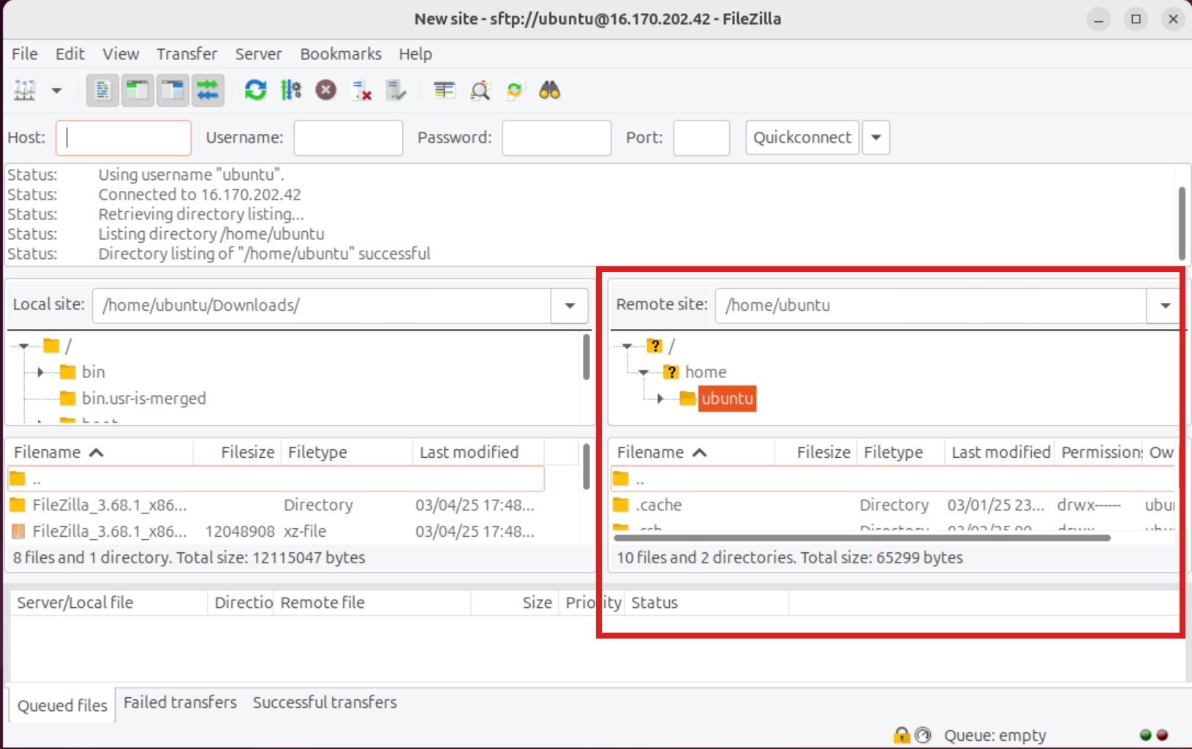

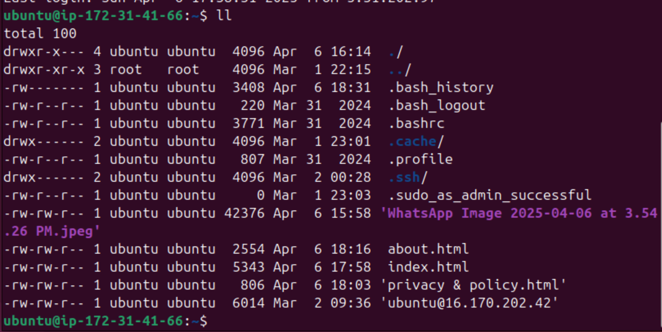

This is a visual representation after the files have been uploaded to my webserver.

1. **Installing and Starting Apache2 - Web Server**:

To host the website, I installed the Apache2 web server on the EC2 instance. The following commands were used:

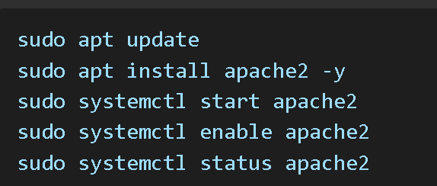

These commands install Apache, start the service, and enable it to run automatically at boot.

1. **Copying HTML Files to the Web Root Directory**:

After uploading the files to the EC2 instance using FileZilla, I moved them into the Apache web root directory using the following commands:

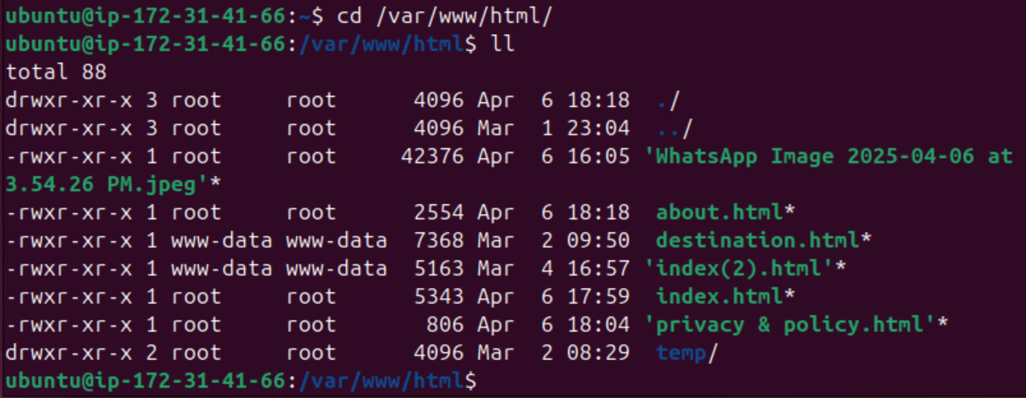

These steps ensure the files are publicly accessible and have proper read permissions for the server.

* + sudo cp -r /home/ubuntu/mywebsite/* /var/www/html/
  + sudo chmod -R 755 /var/www/html

1. **Testing the Website** To verify the deployment, I opened the EC2 public IP address in a web browser. The website loaded successfully, confirming that the Apache server was serving the HTML files properly.



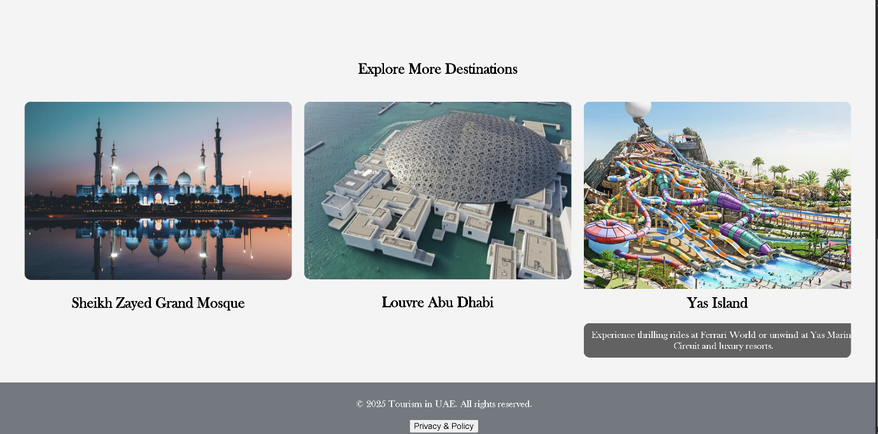

1. **Configuring a domain name and linking with my IP address**

* To purchase a custom domain name, I visited [https://www.namecheap.com] and searched for an available domain for my website to which I selected “zeroxdxb.site” which was available for $1.16, and proceeded to buy it.

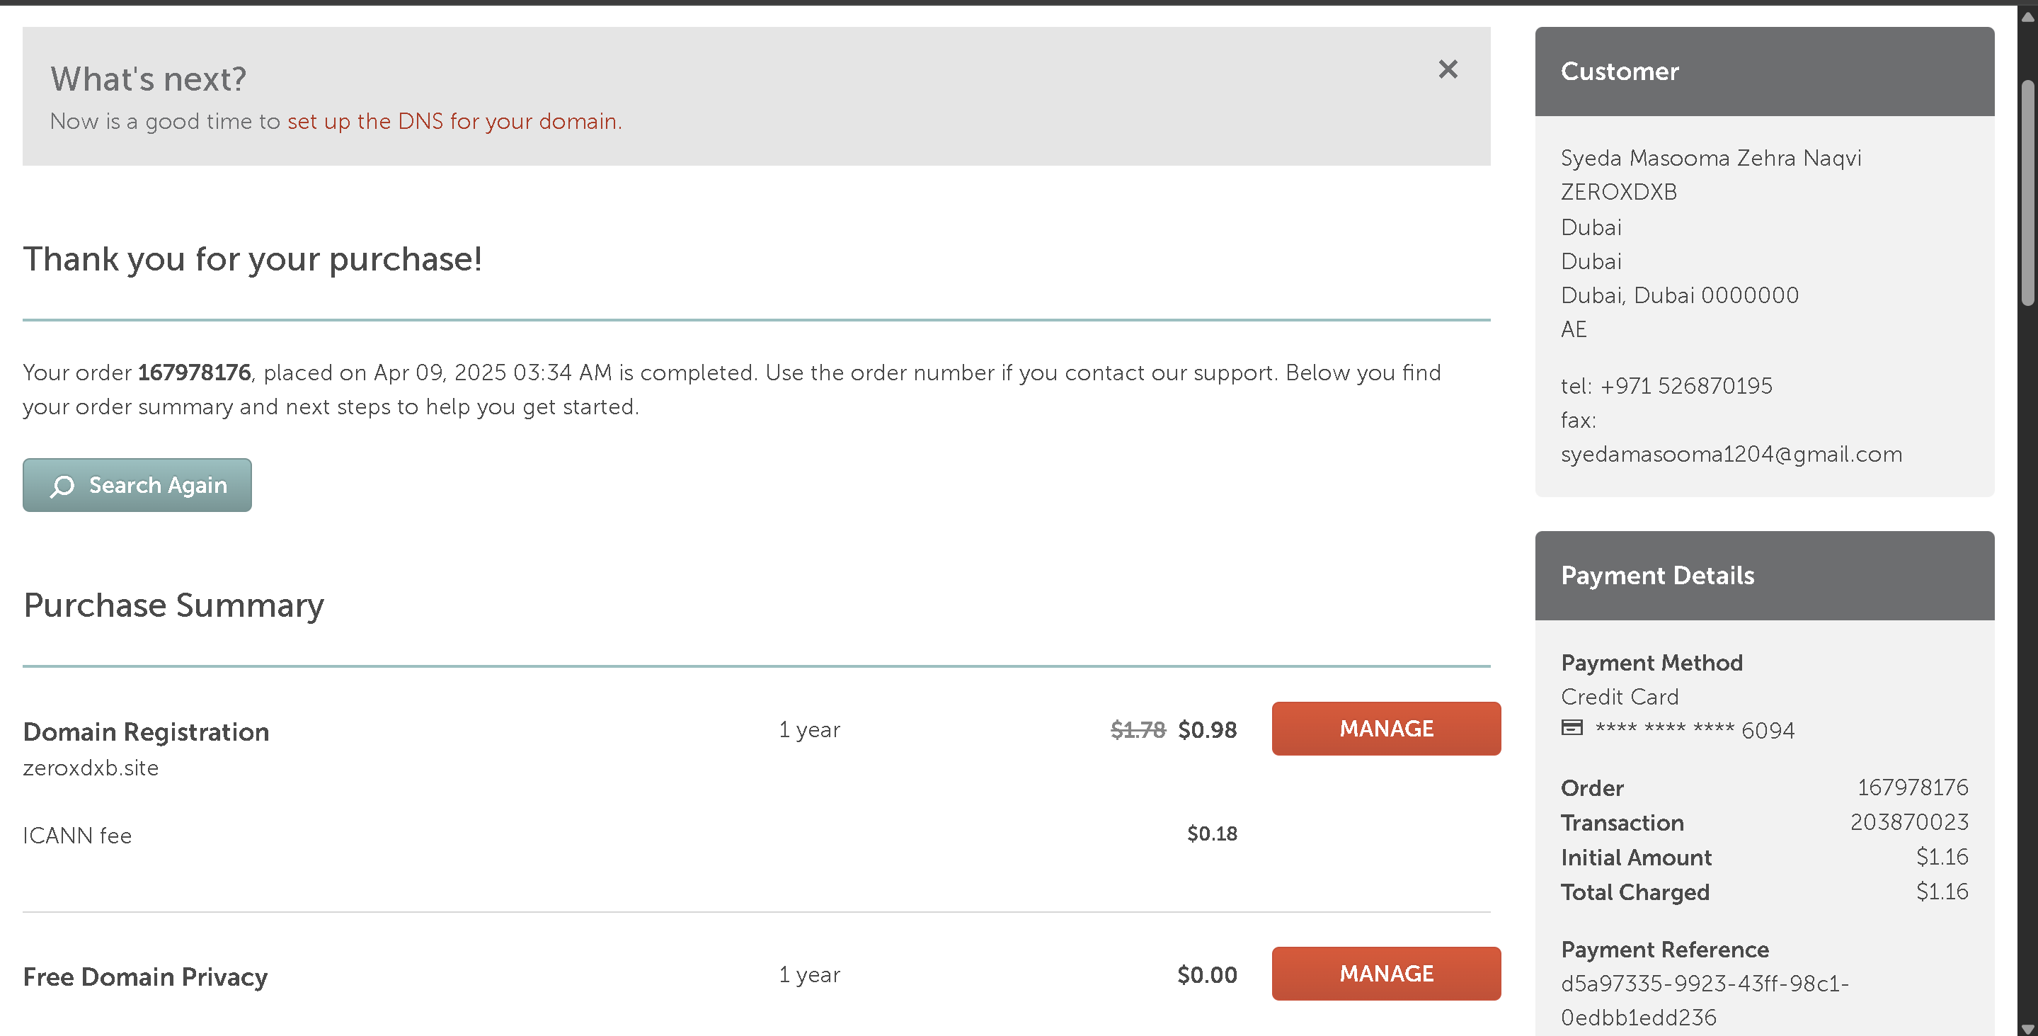

After purchasing the domain, I linked it to my EC2 instance’s public IP address using DNS settings provided by Namecheap.

* Steps to link the domain to EC2 instance:

1. Log in to your Namecheap account and go to Domain List

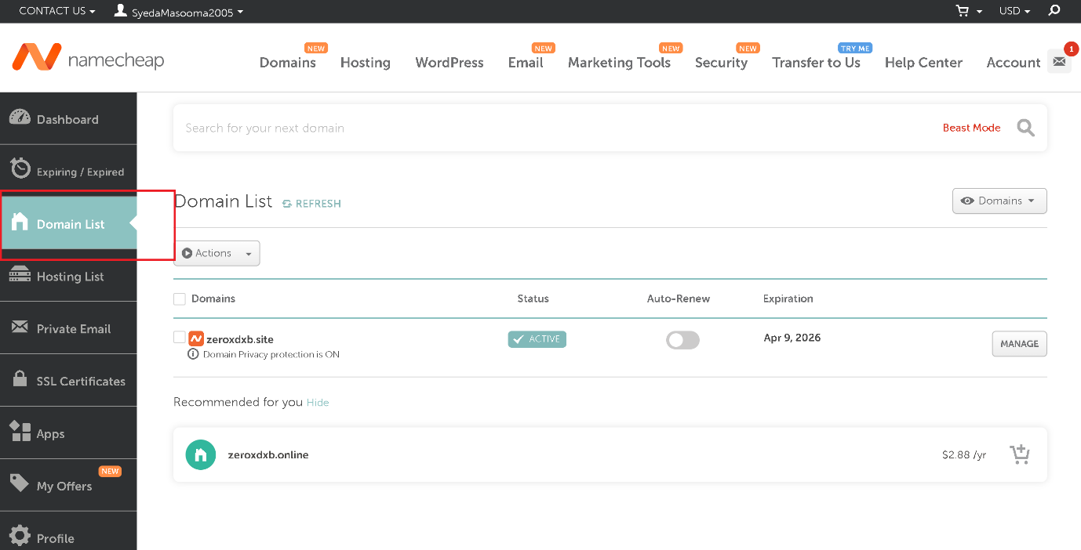

1. Click on Manage next to your domain.

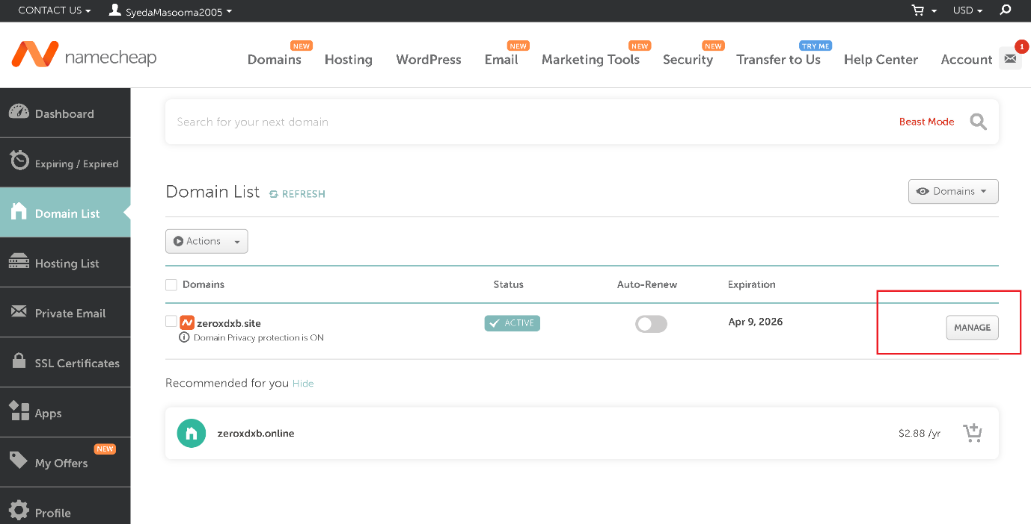

1. Scroll to the “Nameservers” section and select “Namecheap BasicDNS” (if not already selected).

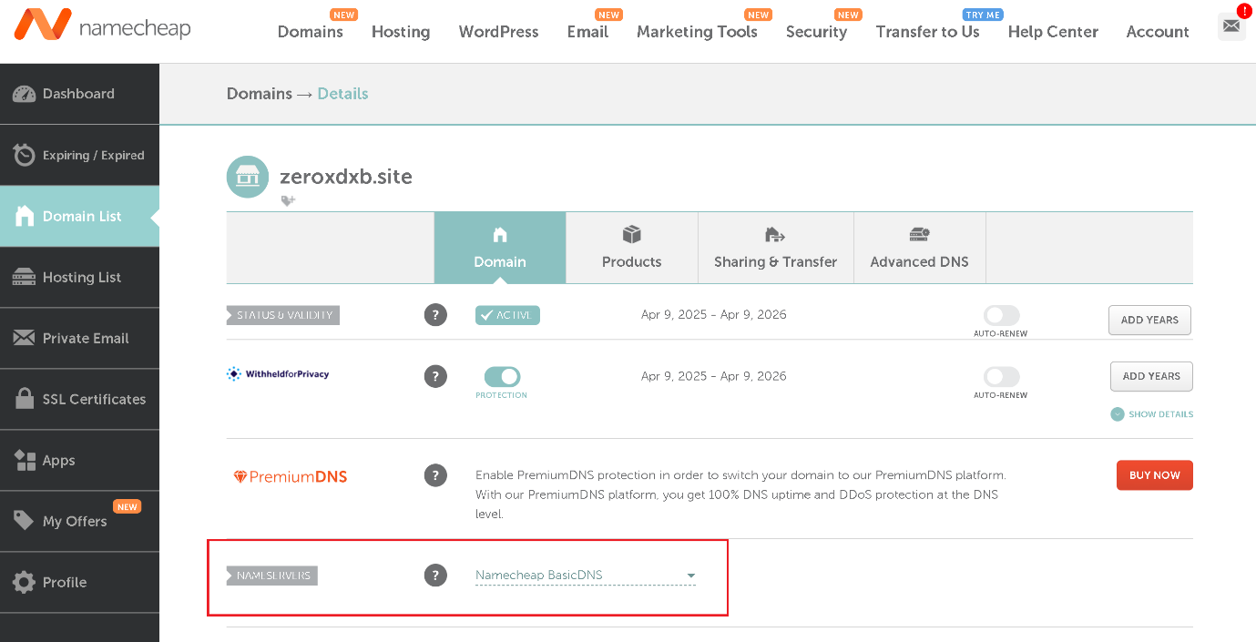

1. Go to the “Advanced DNS” tab.
2. Add a new “A Record”:

* Type: A Record
* Host: `@`
* Value: Your EC2 **public IP address**
* TTL: Automatic

V. Add a second A Record to handle **www**:

* Type: A Record
* Host: `www`
* Value: Your EC2 **public IP address**
* TTL: Automatic

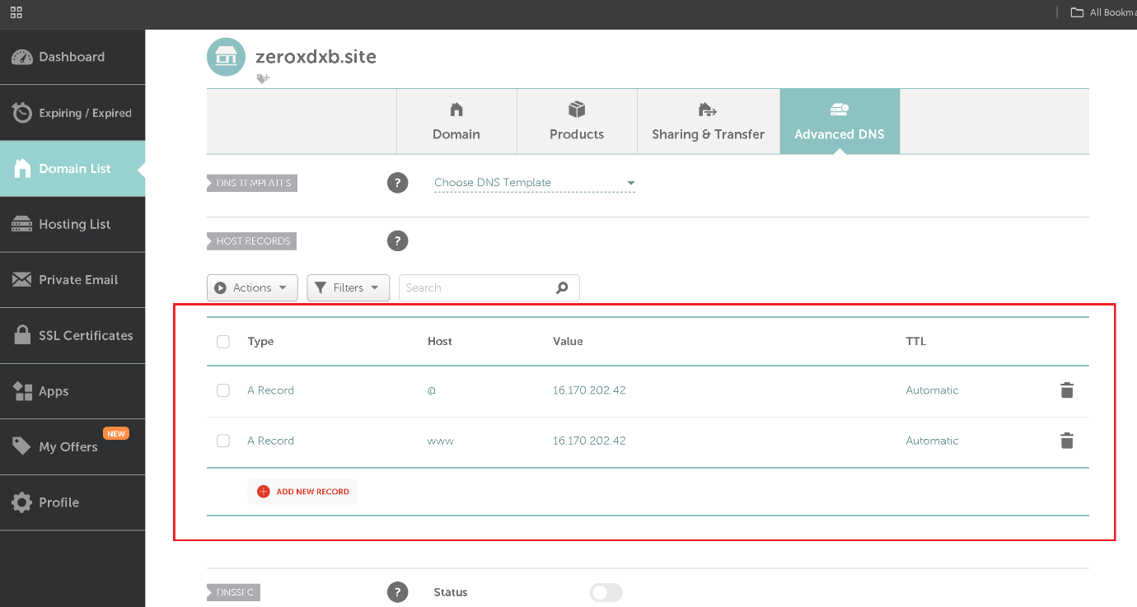

This configuration allowed me to access my website using **zeroxdxb.site** instead of just the EC2 IP address. The domain may take a few minutes to a few hours to propagate globally.

1. **Final Outcome** At this point, the website was live and accessible through the EC2 public IP address & the domain name. The deployment was successful.



1. **Optional Enhancements:**

Additional steps can be taken to enhance the website setup, such as:

* Enabling SSL with Let's Encrypt for HTTPS access to keep it secured
* Installing and enabling UFW (Uncomplicated Firewall)